I have create a instance in AWS and installed docker and now todo app is running in containers

Note: Please see the IP of server where docker is runing **:**

**ubuntu@34.203.202.84**

will attach the key in mail attachment please login and verify

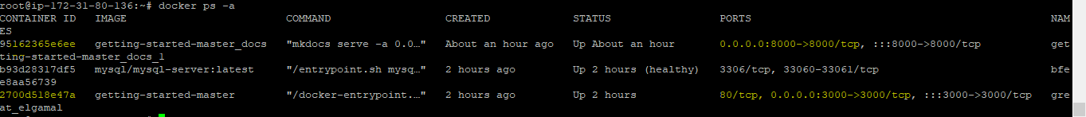

# **One docker container with 3000 port is run from docker file which we got from the git repository**

docker build -t getting-started-master .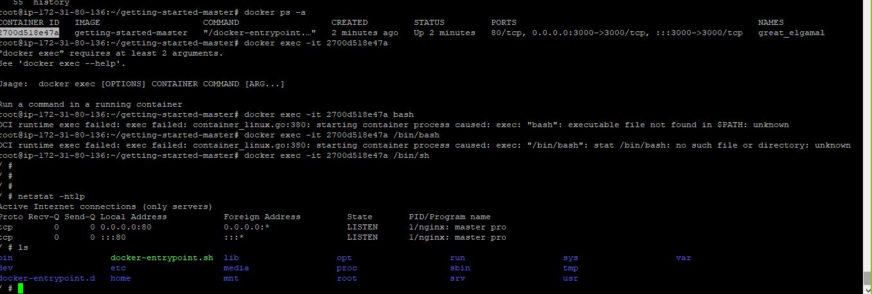

#**The docker container running with 8000 port is run using docker compose file**

sudo curl -L "https://github.com/docker/compose/releases/download/1.29.2/docker-compose-$(uname -s)-$(uname -m)" -o /usr/local/bin/docker-compose

sudo chmod +x /usr/local/bin/docker-compose

docker-compose --version

docker-compose up

docker-compose up –d

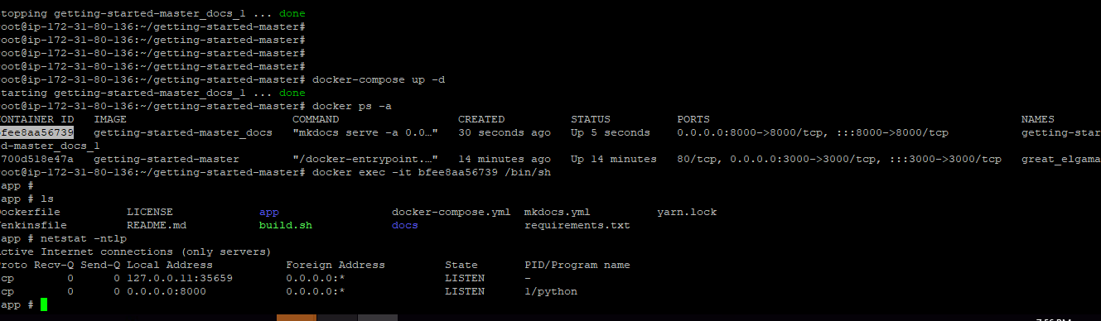

Task2

I have created another ec2 instance for ansible and installed anisble.

Now ansible controller is ready

Inventory hosts is added



Created roles structure



And created connection with anisble controller and client machine, connection success with controller and client.

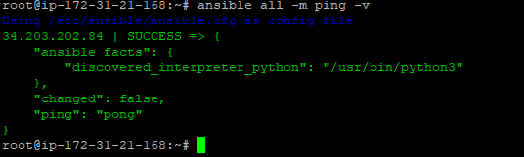

Controller server user name & IP

IP: 54.146.205.244

Username: Ubuntu

Ansible client machine IP and user name

IP : 34.203.202.84

Username: Ubuntu

will attach the key in mail attachment please login and verify

NOTE: Tasks Pending :

Create a deployment playbook using Ansible to be able to easily deploy the complete “Todo” application to on-premise (or cloud) virtual machines without having to do it manually

***Please consider I will try to complete the playbook tomorrow before end line***